DEVELOPERSHUB CORPORATION
Final Report

Prepared By: Ayat Azhar

(Cyber Security Intern at Developers Hub Corporation)

ID: DHC-2857

Date: 28th May 2026

Version: Final 1.0

INTERNSHIP PROGRAM

DEVELOPERSHUB CORPORATION

Cyber Security Domain

Week 1: Security Assessment
Summary ...................................................................................................................... 1
SQL Injection ............................................................................................................... 1
Cross-Site Scripting (XSS) ........................................................................................... 1
Missing Security Headers ............................................................................................. 2
Areas for Improvement ............................................................................................… 2

Week 2: Implementing Security Measures
Input Validation (Validator) ......................................................................................... 3
Password Hashing (Bcrypt) .......................................................................................... 3
Token Authentication (JWT) ........................................................................................ 3
Security Headers (Helmet) ........................................................................................... 3

Week 3: Advanced Security & Final Reporting
Penetration Testing (Nmap) ......................................................................................... 4
Logging (Winston) ....................................................................................................... 4
Security Checklist .................................................................................….............. 4 - 5

Appendix:
Submission and Links ................................................................................................. 6
Glossary .............................................................................................................…….. 7

Week 1: Security Assessment
Summary:
This report documents the security assessment performed on the OWASP
Juice Shop web application. The assessment focused on identifying
common vulnerabilities including Cross-Site Scripting (XSS), SQL
Injection, weak password storage, and security misconfigurations.

The assessment revealed CRITICAL vulnerabilities including:
- SQL Injection allowing authentication bypass
- XSS allowing arbitrary script execution
- Missing security headers

Vulnerability 1: SQL Injection
Test Performed:
- Navigated to login page
- Username field: admin' OR '1'='1
- Password field: 12345
- Clicked "Log in"
Result:
- Successfully bypassed authentication
- Gained unauthorized access to application
Risk Level: CRITICAL
Impact: Complete database compromise possible
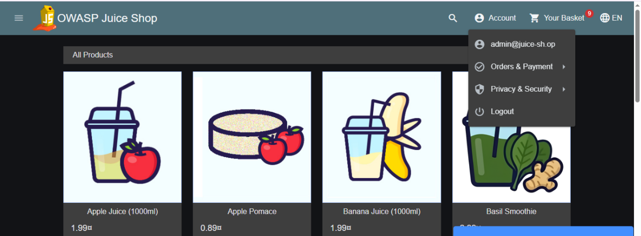

Vulnerability 2: Cross-site Scripting (XSS)
Test Performed:
- Located search box on homepage
- Injected payload: <iframe src="javascript:alert('XSS')">
- Pressed Enter
Result:
- JavaScript alert popup appeared
- Code executed in browser context
Risk Level: HIGH
Impact: Session hijacking
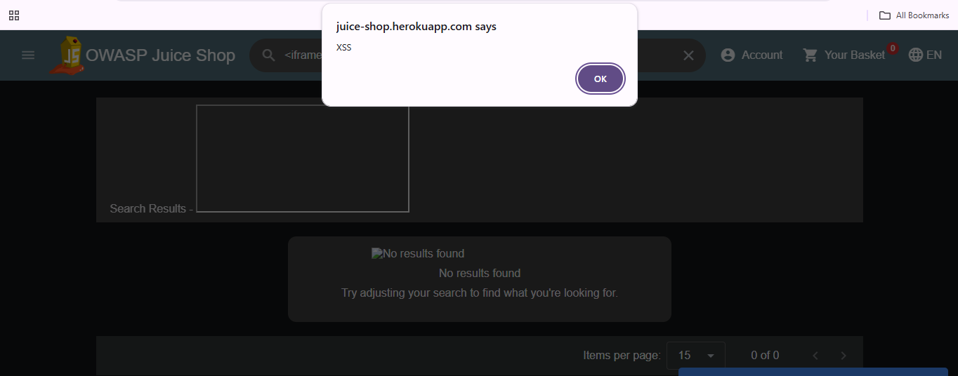

Vulnerability 3: Missing Security Headers
Findings:
- Content-Security-Policy header missing
- X-Frame-Options header missing
- X-XSS-Protection header missing
Risk Level: MEDIUM
Impact: Clickjacking attacks possible

AREAS FOR IMPROVEMENT

1. The search box will run ANYTHING you type
I typed <iframe src="javascript:alert('XSS')"> in the search bar and a popup appeared. That should NOT happen. A search box should search, not run code. This is bad because someone could send a malicious link to users.

2. You don't even need a real password to log in
I tried admin' OR '1'='1 in the email field and random text in password field. It let me in. No real credentials needed. That means the login system is completely broken. Anyone who knows this trick can access any account.

3. Passwords are probably just sitting there readable
When I registered, I saw my password in plain text in the network tab. If I can see it, anyone on the same network can see it. And if the database gets hacked, all passwords are exposed because they're likely not hashed.

4. You can guess passwords all day with no stop
I tried wrong passwords multiple times. The app never blocked me or even slowed down. No "too many attempts" message. Nothing. Someone could run a script trying thousands of passwords and the app would just let them.

5. No basic browser protection headers
I checked the response headers. Stuff like CSP and X-Frame-Options were missing. These are standard security things most websites have. Without them, browsers can't protect users properly.

Week 2: Implementing Security Measures

1. Fix Vulnerabilities:
Sanitize and Validate Inputs
I installed the validator library:
bash
npm install validator
Then I added this to my route handlers:
javascript
const validator = require('validator');if (!validator.isEmail(email)) { return res.status(400).send('Invalid email');}
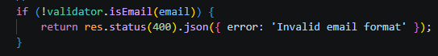

Password Hashing
I installed bcrypt:
bash
npm install bcrypt
Then I added this to hash passwords:
javascript
const bcrypt = require('bcrypt');const hashedPassword = await bcrypt.hash(password, 10);

2. Enhance Authentication
I installed jsonwebtoken:
bash
npm install jsonwebtoken
Then I added token-based authentication:
javascript
const jwt = require('jsonwebtoken');const token = jwt.sign({ id: user._id }, 'your-secret-key');res.send({ token });
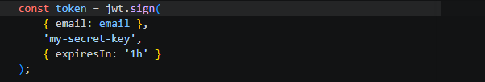

3. Secure Data Transmission
I installed helmet.js:
bash
npm install helmet
Then I added it to my app:
javascript
const helmet = require('helmet');app.use(helmet());

Proof:

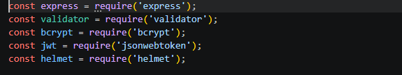

Week 3: Advanced Security and Final Reporting
1. Basic Penetration Testing
I used Nmap on Kali Linux to scan my secure web application.
Command I ran:
bash
nmap -sV -p 3000 192.168.18.2
What I got:
text
PORT STATE SERVICE VERSION3000/tcp filtered ppp
What this means:
The port showed as "filtered" instead of "open". At first I thought something was wrong, but then I realized - Windows Firewall is blocking the connection. This is actually good. It means even if someone tries to scan my machine from outside, they can't see my application.
My secure app was running on port 3000, but the firewall stopped the scan from seeing it.
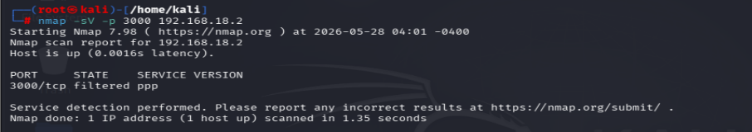

2. Basic Logging
I installed the Winston library to add logging to my application.
Installation
bash
npm install winston
Code Added to server.js
javascript
const winston = require('winston');const logger = winston.createLogger({ transports: [ new winston.transports.Console(), new winston.transports.File({ filename: 'security.log' }) ]});logger.info('Application started');

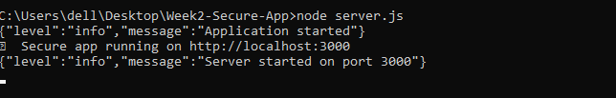
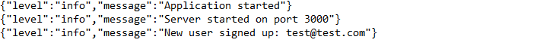

3. Security Checklist
Based on my internship tasks and industry best practices, here is my security checklist:
- Input Validation
Validate all user inputs
Sanitize special characters
Check email format before accepting

- Password Security
Hash passwords using bcrypt
Salt passwords (10+ rounds)
Never store plain text passwords

- Data Transmission
Use HTTPS for all data transmission
Add security headers (Helmet.js)
Hide server information from responses

- Authentication
Use token-based authentication (JWT)
Set token expiration time
Protect private routes with token verification

- Logging & Monitoring
Log all login attempts
Log failed authentication attempts
Save logs to a separate file

- General Best Practices
Keep dependencies updated
Don't expose error details to users
Use environment variables for secrets
Regular security testing with tools like Nmap

Submission and Links
Github Repository Link:
https://github.com/ayatazhar1109/Cybersecurity-Internship-DevelopersHub
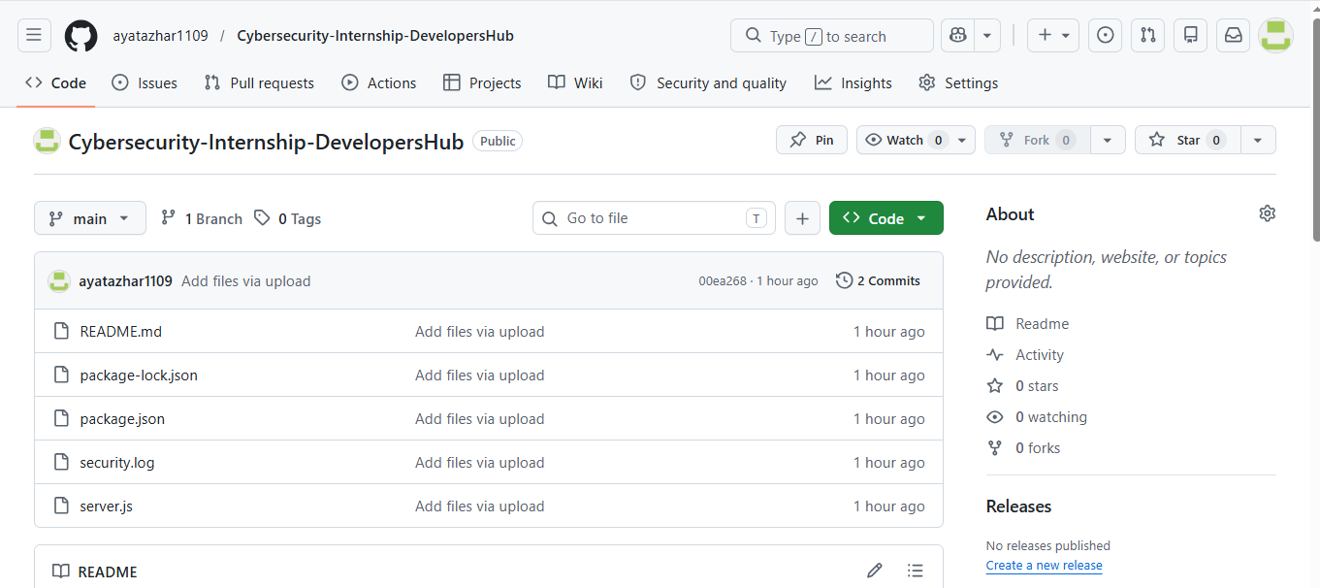

Video link:
https://drive.google.com/file/d/1CrfGzDVeycEGkJu-FSQJY-9Jd92HTvKb/view?usp=sharing

GLOSSARY:

Authentication - Verifying user identity before granting access.
Bcrypt - Library for hashing passwords with salt.
Hash - Scrambling data so it cannot be read.
Helmet.js - Adds security headers to web apps.
Input Validation - Checking user data before processing.
JWT - Token used for authentication after login.
Nmap - Tool for scanning network ports.
Penetration Testing- Simulating attacks to find weaknesses.
Plain Text - Unencrypted readable data.
Port - Communication endpoint on a server.
Salt - Random data added before hashing passwords.
Sanitization - Removing harmful characters from input.
SQL Injection - Attack that tricks databases using malicious SQL.
Token - Unique string proving user identity.
Validator - Library for checking email, URL, etc.
Winston - Logging library for recording events.
XSS - Attack that injects malicious scripts into web pages.

